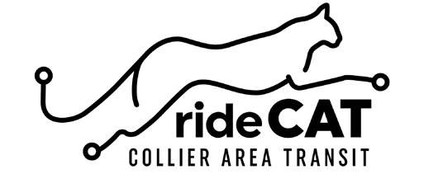

Perk Pass

Employer Enrollment Form
Employer Information

Company: # of Employees: Contact Name: Contact Position: Contact Email: Business Address:

City:
State:
Zip:

Business Phone: Contact Phone:

30-Day Perk Pass Only $29.75

Initial
I certify that the number of employees is correct to my knowledge and that the business qualifies under the terms of the Perk Pass program. I understand each employee enrolled is responsible for payment in the amount of $29.75 at the beginning of each month for participation in the Perk Pass program. The CAT 30-Day pass is not subject to refund and/or transfer. Perk Pass excludes express routes.

Please enroll this business into the Perk Pass program. 30-Day Perk Passes will be void at
termination of employment.

Employer Contact Signature Date

Submit Completed Form to Collier Area Transit
8300 Radio Rd, Naples FL 34104 rideCAT@CollierCountyFL.gov For questions call 239-252-7777

