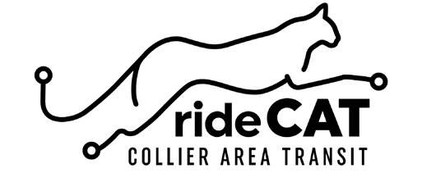

Perk Pass Enrollment Form
Employee Information

Company:
Supervisor Name: Supervisor Email:
Employee Name: Employee Email:
Business Address:

City:
State:
Zip:

Business Phone: Employee Phone:

30-Day Perk Pass Only $29.75

Initial
I understand I am responsible for payment in the amount of $29.75 at the beginning of each month for participation in the Perk Pass program. The CAT 30-Day pass is not subject to refund and/or transfer. Perk Pass excludes express routes.

Please enroll me into the Perk Pass program. 30-Day Perk Pass will be void at termination of employment.

Employee Signature Date

Supervisor Signature Date

Submit Completed Form to Collier Area Transit
8300 Radio Rd, Naples FL 34104 rideCAT@CollierCountyFL.gov For questions call 239-252-7777

